**AI ASSISTED CODING **

**Lab-14.5**

**NAME:** D. Nagamrutha

**ROLLNO:**2503A51L06

**Task 1: AI-Assisted Portfolio Website**  
**Scenario:**  
A student wants to showcase their projects, skills, and contact details in  
a portfolio website. Instead of writing all code manually, they want to  
speed up the process using GitHub Copilot.  
• Use Copilot to generate an HTML structure for a personal  
portfolio page (sections: Home, About, Projects, Contact).  
• Ask Copilot to suggest responsive CSS styling for the layout  
(e.g., grid/flexbox).  
• Customize Copilot’s suggestions to add a hover effect on project  
cards

**PROMPT:**

generate an HTML structure for a personal portfolio page (sections: Home, About, Projects, Contact).suggest responsive CSS styling for the layout (e.g., grid/flexbox).add a hover effect on project cards give html CSS in same file.

**Code Generated:**

**Output:**

**OBSERVATION:**

The code builds a responsive personal portfolio webpage with four main sections: Home, About, Projects, and Contact. It uses flexbox and CSS grid for layout, ensuring adaptability across screen sizes. The navigation is sticky, the project cards include a hover effect (lift + shadow), and a simple contact form is provided, making the design clean, modern, and user-friendly.

**Task 2: AI-Generated Restaurant Landing Page  
Scenario:**A local restaurant needs a simple landing page with a navigation bar,  
menu highlights, and an image gallery. The developer wants to quickly  
generate it using AI assistance.  
• Use Copilot to create a navigation bar with links (Home, Menu, Gallery, Contact).  
• Generate a menu section styled with CSS cards.  
• Add a JavaScript-based image slider for the gallery, with  
Copilot suggesting the base code

**PROMPT:**

A local restaurant needs a simple landing page with a navigation bar, menu highlights, and an image gallery.

•create a navigation bar with links (home, menu, gallery, contact).

• generate a menu section styled with CSS cards.

• add a JavaScript-based image slider for the gallery, give all three codes in a single file.

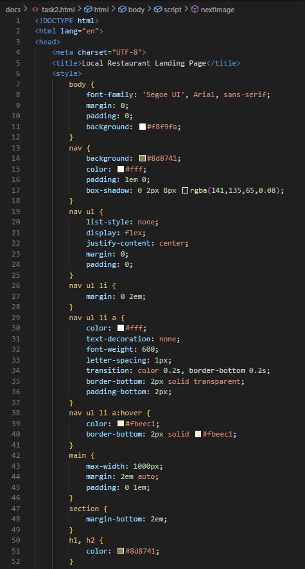**Code Generated:**

**Output:**

**Observation:**

The code designs a simple and responsive restaurant landing page with a sticky navigation bar, a section styled menu using CSS cards, and an interactive JavaScript-based image slide for the gallery. The layout is clean, user-friendly, and effectively highlights the restaurant’s offerings while ensuring easy navigation.

**Task 3: AI-Powered Event Registration Form  
Scenario:**  
SR University is hosting a tech fest. They need a web-based registration  
form for students. The form must validate user input in real-time.  
• Ask Copilot to generate an HTML form (fields: Name, Email,  
Phone, Department, Event Selection).  
• Use Copilot to assist in adding CSS styling for an attractive form  
layout.  
• Implement JavaScript validation (e.g., email format check,  
phone number length check) using Copilot’s suggestions.

**PROMPT:**

SR University is hosting a tech fest. They need a web-based registration form for students. The form must validate user input in real-time. generate an HTML form (fields: Name, Email, Phone, Department, Event Selection). assist in adding CSS styling for an attractive form layout.

• Implement JavaScript validation (e.g., email format check,

phone number length check) using Copilot’s suggestions. Give js html CSS in single file.

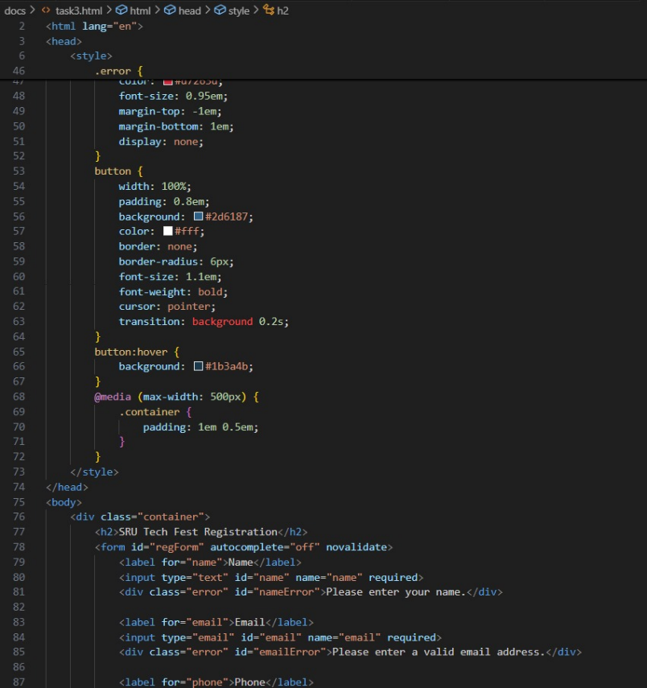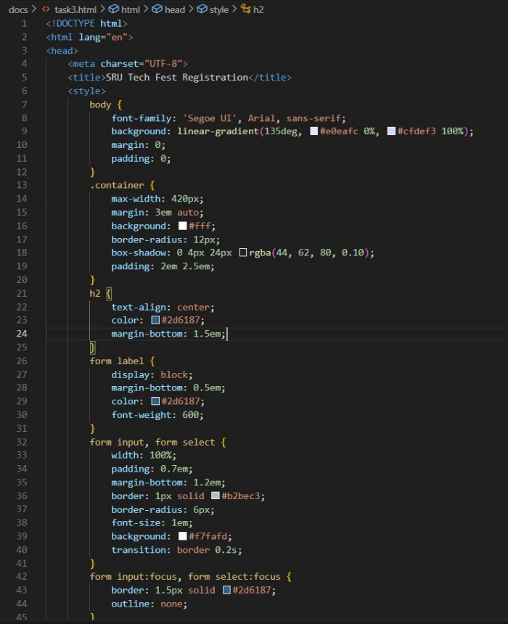**Code Generated:**

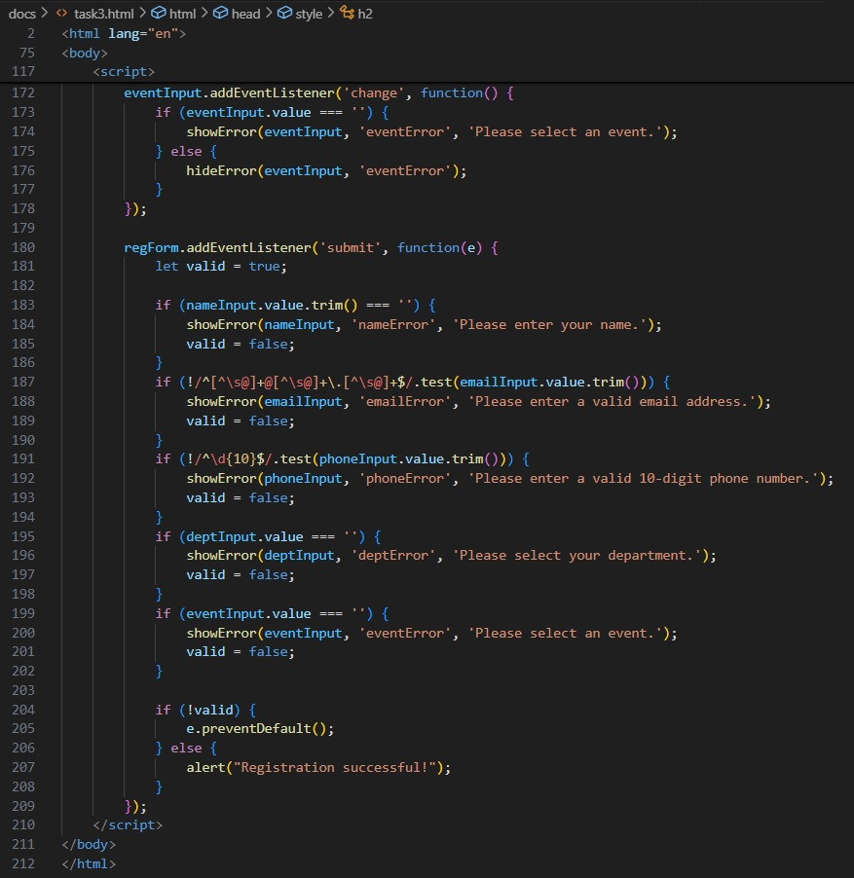

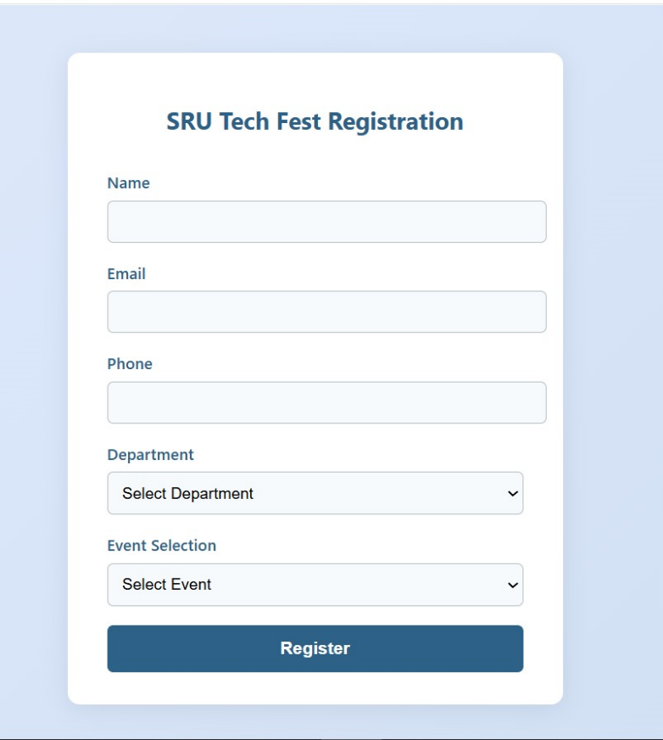**Output:**

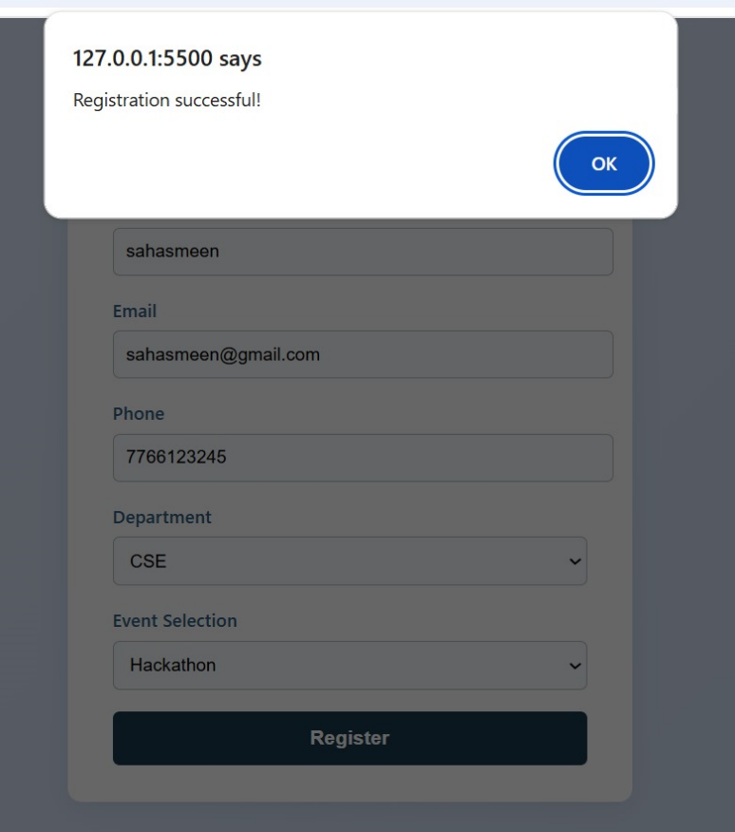

**Observation:**

The code provides a **modern, responsive registration form** with fields for student details and event selection. It uses **CSS for an attractive layout** and **JavaScript for real-time validation** (checking email format, phone length, and required fields). Error messages are displayed instantly, and a success message confirms registration, making the form both user-friendly and reliable.

**Task 4: AI-Assisted E-Commerce Product Page  
Scenario:**A startup wants a basic e-commerce product page to display products  
with prices and an “Add to Cart” button.  
• Use Copilot to generate a grid-based product catalog in  
HTML/CSS.  
• Implement a JavaScript “Add to Cart” functionality with  
Copilot’s guidance.  
• Modify Copilot’s suggestions to include a cart counter at the  
top-right corner of the page.

**PROMPT:**

A startup wants a basic e-commerce product page to display products

with prices and an “Add to Cart” button. Generate a grid-based product catalog in HTML/CSS. Implement a JavaScript “Add to Cart” functionality

Include a cart counter at the top-right corner of the page. give html,css and js in the same file.

**Code Generated:**

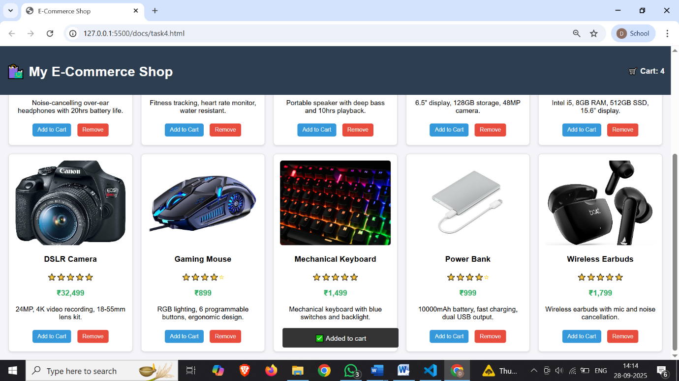**Output:**

**OBSERVATION:**

The code creates a basic e-commerce product page using HTML, CSS, and JavaScript in a single file. It displays products in a responsive grid layout with images, names, prices, and an “Add to Cart” button. A cart counter is placed at the top-right corner inside the header and dynamically updates whenever the user clicks “Add to Cart.” The implementation is simple, lightweight, and serves as a starting point for building a full shopping cart system.